* Manually created a EC2 instance, S3 bucket(to store terraform statefile), IAM Role and dynamodb with LockID enabled(to lock the terraform statefile)
* That IAM ROLE which needs to be attached to the Jenkins Server(EC2 instance) should have following policies-

1. AmazonEC2FullAccess
2. AmazonS3FullAccess
3. AmazonDynamoDBFullAccess

* Login to Jenkins server🡪 Pipeline🡪
* 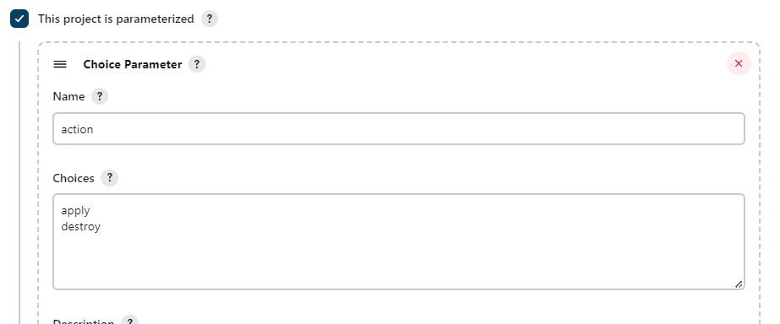
* Under pipeline use the following Script
* pipeline {
* agent any

stages {

stage('checkout') {

steps {

checkout([$class: 'GitSCM',

branches: [[name: '\*/master']],

extensions: [],

userRemoteConfigs: [[url: 'https://github.com/nikhi5699/Jenkins-Terraform']]

])

}

}

stage('init') {

steps {

sh "terraform init -reconfigure"

}

}

stage('plan') {

steps {

sh "terraform plan -lock=false"

}

}

stage("action") {

steps {

echo "Terraform action is --> ${action}"

sh "terraform apply -lock=false --auto-approve"

}

}

}

}

* Configure the pipeline and try to build with the parameters.
* Instance, Vpc and Security Group, Eip and S3 buckets are created.
* Output should be something like